This submission template is a convenient document for you to provide the screenshots and explanations for Assignment 5.0. This submission template is intended to be used in conjunction with the Assignment 5.0 Instructions document. The instructions document illustrates how to correctly execute each SQL construct, explains important theoretical and practical details, and contains the complete set of instructions on how to complete this lab.

**Name**: Mi Gao

**Date: 08/10/2020**

**Section Two**

The screenshots needs to show your user name and the date loaded.

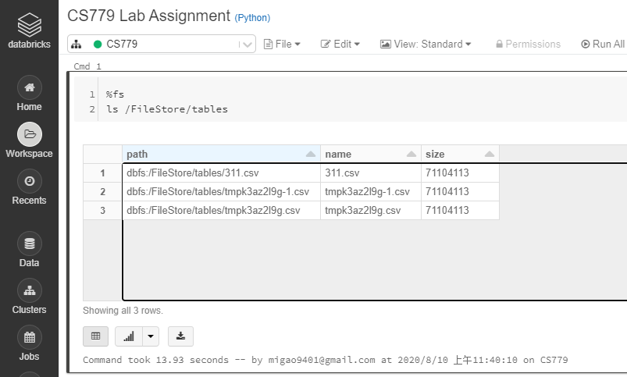

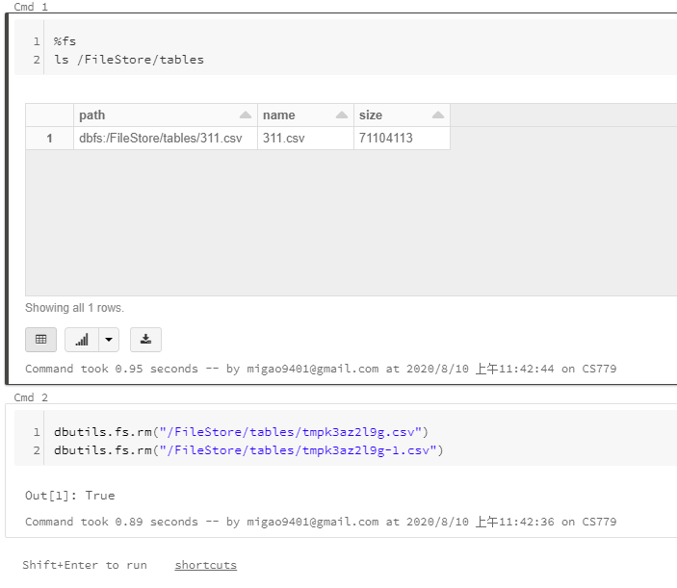

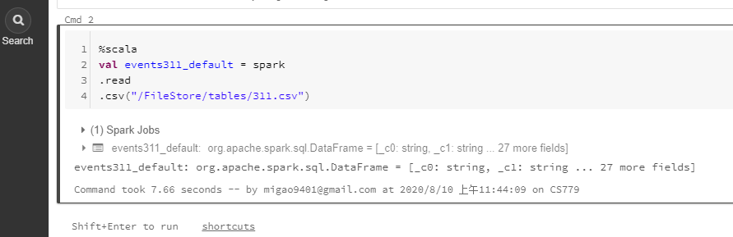

28. Screenshot of the loaded data frame.

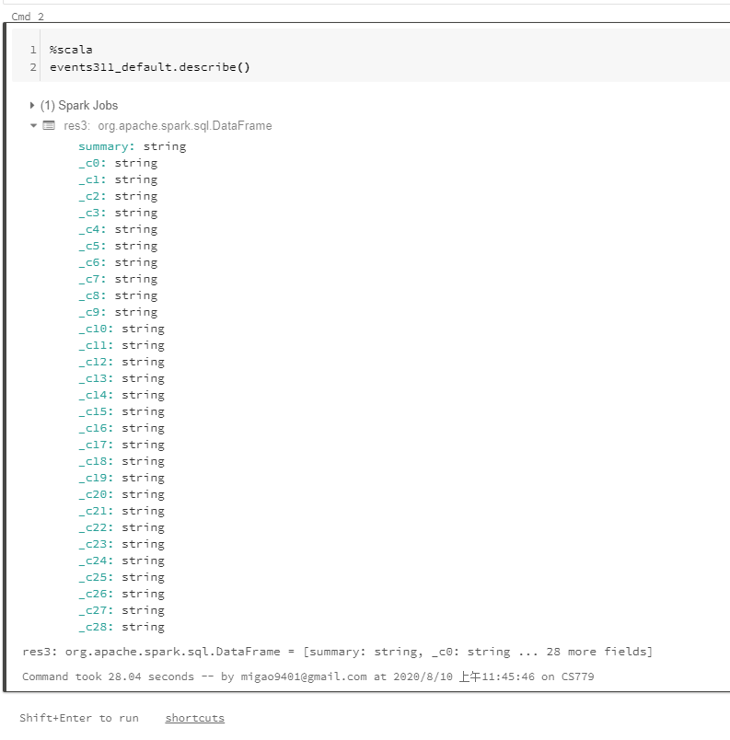

29. How many c fields are listed? __29 c files which from c0 to c28.___

32. Provide the query command and the resulting data set

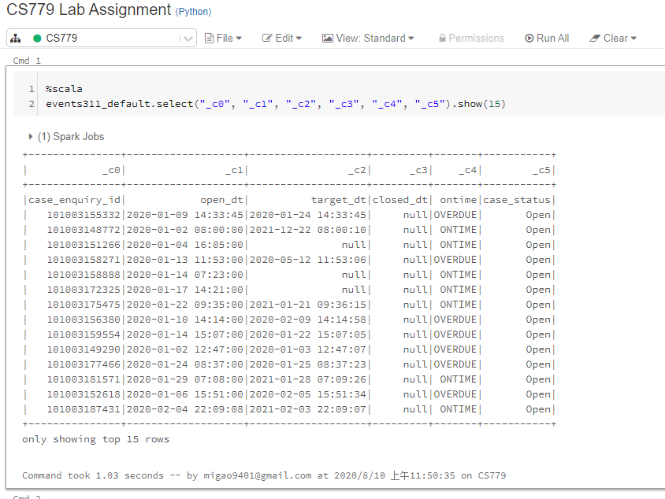

35. Provide the query command and the resulting data set

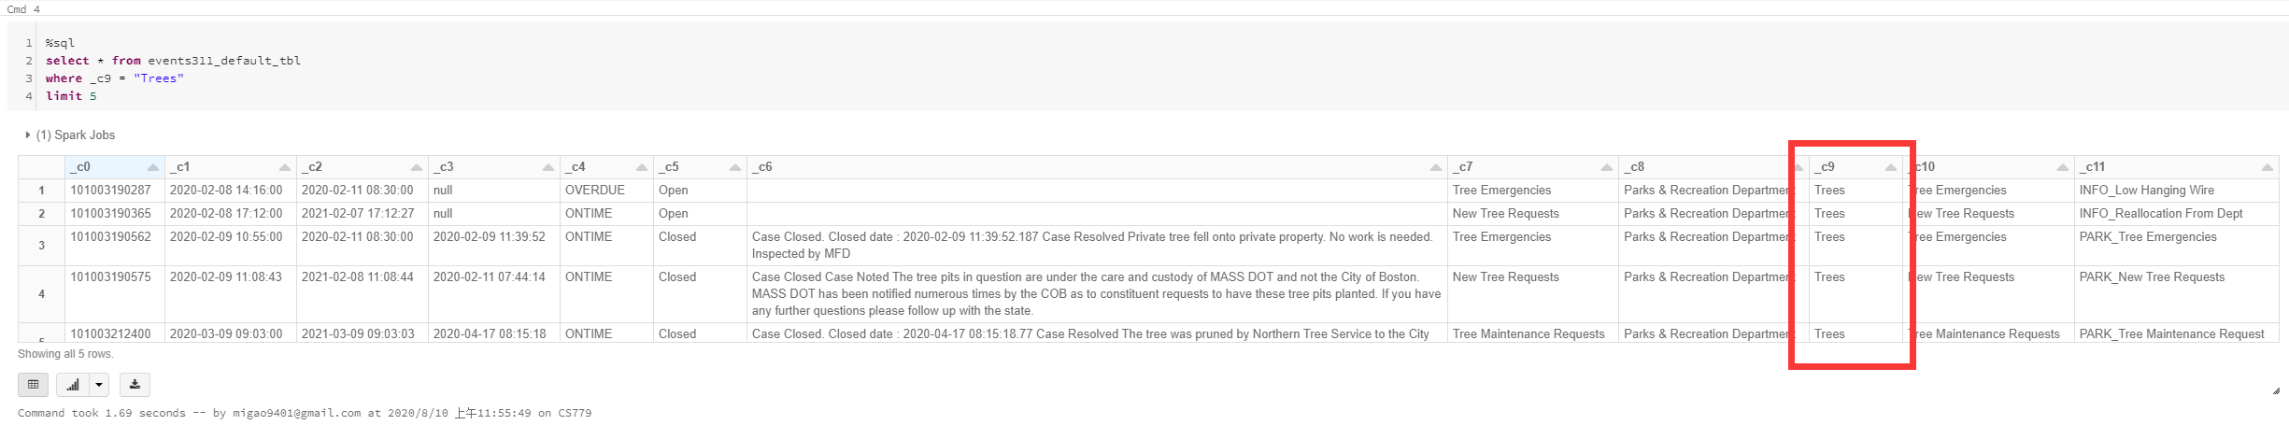

39. Provide the query command and the resulting data set

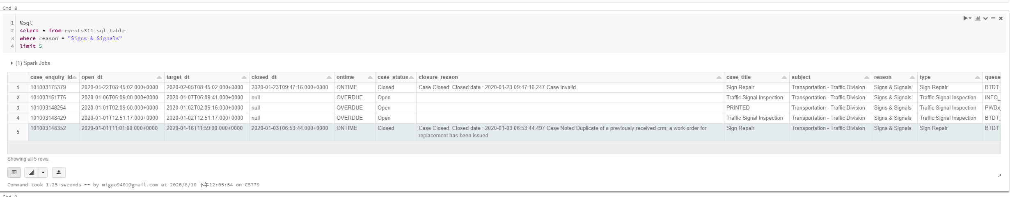

40. Provide the query command and the resulting data set including chart

**I will provide several queries progressively to make my answer in this question looks more meaningful.**

**I am going to check how many cases have around Boston area. I thing this should be meaningful.**

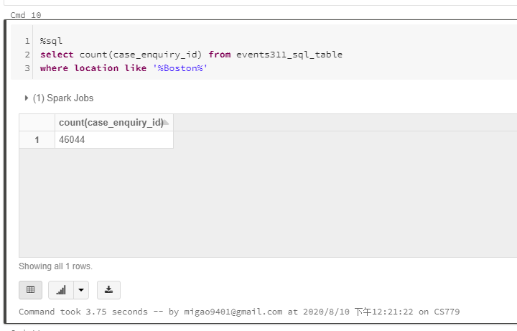

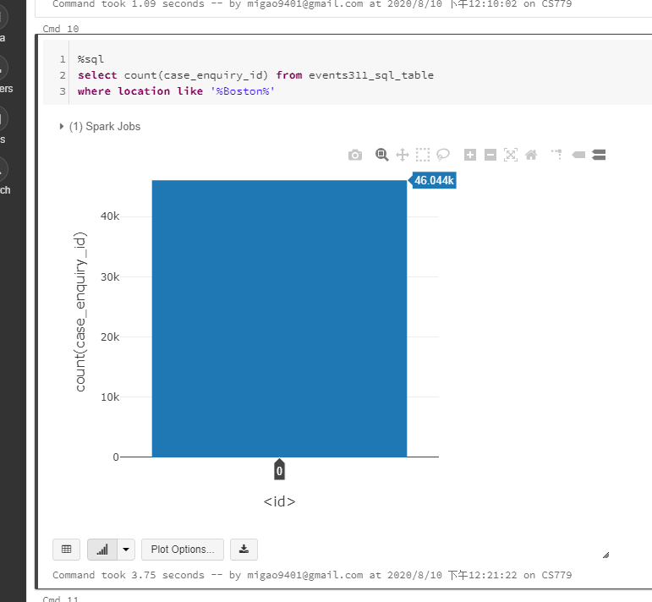

**Or keep going, to check each month case opened because aggregation above might be too simple:**

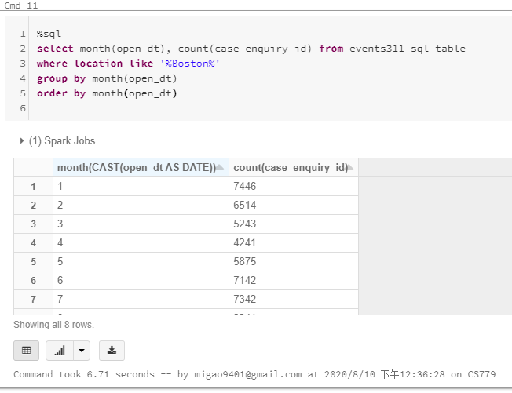

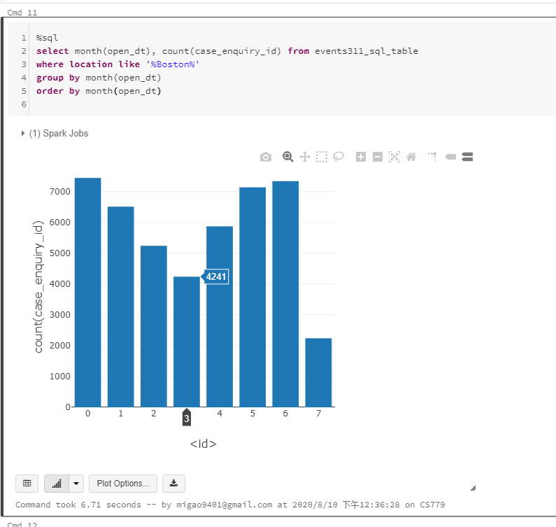

**Well, interesting; April got the minimal number of cases without August which is not end in 2020 so far. Moreover, let’s just see the case details based on the reasons in the end.**

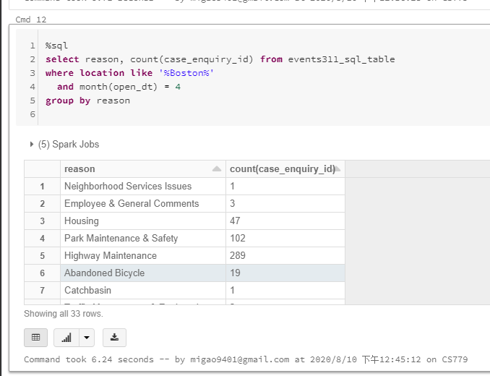

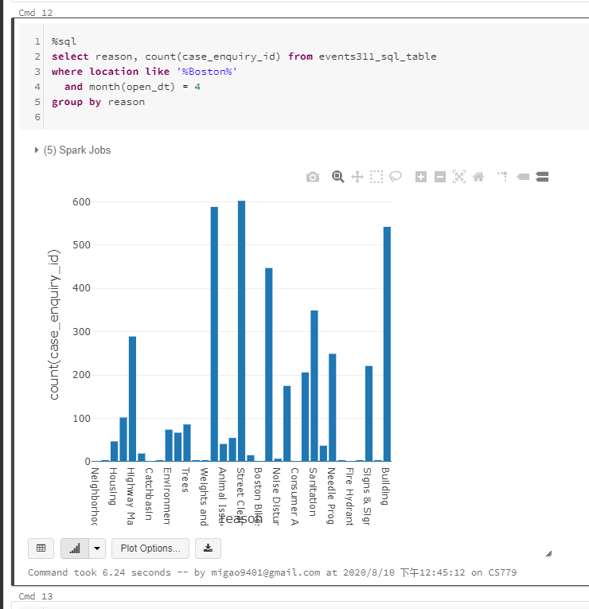

41. Very briefly explain what you have discovered based on your data set from the query above.

**In first half year of 2020, March is the month which has the minimal cases. Something might be the reason which caused this result. We may keep looking at or comparing with another months to find which things will be the main reason let the number of case down in April.**

Use the **Ask your Facilitator Discussion Board** if you have any questions regarding the how to approach this assignment.

Save your assignment as ***lastnameFirstname_lassignment5.doc*** and submit it in the *Assignments* section of the course.

For help uploading files please refer to the *Technical Support* page in the syllabus.

Your lab submission will be evaluated according to the following rubric.

|  |  |  |
| --- | --- | --- |
|  | **Letter Grade** | **Qualities Demonstrated by the Lab Submission** |
| **Correctness, completeness, and constitution**  **Measures the correctness and completeness of the results, and the quality of the constitution of the SQL constructs** | A+ 🡺 100 | The results and explanations are entirely complete and correct for all steps. There are absolutely no technical or other errors present. There is no known way to improve the logic and makeup of any of the SQL constructs. |
| A 🡺 96 | One insignificant technical or other error is present, but otherwise the results and explanations are entirely complete and correct for all steps. Excluding the insignificant error, there is no known way to improve the makeup of any of the SQL constructs. |
| A- 🡺 92 | One or two consequential technical or other errors are present, but otherwise the results and explanations are entirely complete and correct for all steps. Excluding the one or two errors, there is no known way to improve the makeup of any of the SQL constructs. |
| B+ 🡺 88 | A few steps have significantly incomplete or incorrect results or explanations. The results and explanations are complete and correct for the remainder of the steps. The logic and makeup of most SQL constructs are sound. |
| B 🡺 85 | A few steps have significantly incomplete or incorrect results or explanations. The results and explanations are mostly complete and correct for the remainder of the steps, with the exception of a few insignificant technical or other errors. The logic and makeup of most SQL constructs are sound. |
| B- 🡺 82 | About ¼ of the steps have significantly incomplete or incorrect results or explanations. The results and explanations are complete and correct for the remainder of the steps. The logic and makeup of at least ¾ of the SQL constructs are sound. |
| C+ 🡺 78 | About ¼ of the steps have significantly incomplete or incorrect results or explanations. The results and explanations are mostly complete and correct for the remainder of the steps, with the exception of a few insignificant technical or other errors. The logic and makeup of at least ¾ of the SQL constructs are sound. |
| C 🡺 75 | About half of the steps have significantly incomplete or incorrect results or explanations. The results and explanations are complete and correct for the remainder of the steps. The logic and makeup of at least half of the SQL constructs are sound. |
| C- 🡺 72 | About half of the steps have significantly incomplete or incorrect results or explanations. The results and explanations are mostly complete and correct for the remainder of the steps, with the exception of a few insignificant technical or other errors. The logic and makeup of at least half of the SQL constructs are sound. |
| D 🡺 67 | About ¾ of the steps have significantly incomplete or incorrect results or explanations. The results and explanations are complete and correct for the remainder of the steps. The logic and makeup of at least ¼ of the SQL constructs are sound |
| F 🡺 0 | All or almost all of the steps have incomplete or incorrect results or explanations. The logic and makeup of all or almost all of the SQL constructs are unsound. |